

NWDPWR – CIPMS CBP Payment and Infrastructure Project Management System Architecture

CONTRACT NO: PWR 107/22
DESCRIPTION: PROJECT, PROGRAMME AND PORTFOLIO MANAGEMENT TO PROJECT, PROGRAMME AND PORTFOLIO MANAGEMENT (PPPM) SERVICES FOR THE NORTH WEST DEPARTMENT OF PUBLIC WORKS AND ROADS FOR A PERIOD OF THIRTY-SIX (36) MONTHS
DOCUMENT CONTROL SHEET
The purpose of this form is to ensure that documents are reviewed and approved prior to issue. The form is to be bound into the front of all documents issued by GO BENG DBG PROJECTS (PTY) LTD JOINT VENTURE
DOCUMENT PROPERTIES
Item | Description
Document Title | CIPMS CBP Payment and Infrastructure Project Management System Architecture
Client | NORTH WEST PUBLIC WORKS AND ROADS
Consultant | GO BENG CONSULTING - DBG PROJECTS (PTY) LTD JOINT VENTURE
Document Status
Date
VERSION CONTROL
Version | Prepared By | Signature
FIRST DRAFT | Stefan van Tonder
Version | Reviewed By | Signature
FIRST REVIEW
Version | Approved By | Signature
SECOND REVIEW

APPROVED FOR EXTERNAL ISSUE BY
Version | Approved By | Signature
FINAL REPORT | Phumza Smith

TABLE OF CONTENTS
CIPMS - CBP PAYMENT AND INFRASTRUCTURE PROJECT MANAGEMENT SYSTEM ARCHITECTURE 5
1. INTRODUCTION 5
1.1 Purpose 5
1.2 Scope 6
2. TECHNOLOGY STACK 6
2.1 Core Technologies 6
2.2 Hosting Environment 7
3. LOGICAL ARCHITECTURE 7
3.1 Architecture Pattern 7
3.2 Application Layers 7
3.3 Data Flow Overview 8
4. INTEGRATION ARCHITECTURE 8
4.1 Integration Overview 8
4.2 API Specifications 8
4.3 SmartGov Integration (Planned) 9
4.4 Integration Considerations 9
4.5 Future Integration Support 9
5. SECURITY ARCHITECTURE 10
5.1 Security Principles 10
5.2 Authentication 10
5.3 Authorization 10
5.4 Data Protection 10
5.5 Audit Logging 10
5.6 Session Management 10
5.7 Monitoring & Threat Detection 11
6. COMPLIANCE MAPPING 11
7. OPERATIONAL ARCHITECTURE 12
7.1 Backup Strategy 12
7.2 Disaster Recovery 12
7.3 Monitoring & Alerting 12
7.4 Scalability 13
7.5 Capacity Planning 13
8. TECHNICAL SPECIFICATIONS 13
8.1 Application 13
8.2 Database 13
8.3 Web Server 13
8.4 Networking 14
9. GOVERNANCE AND APPROVAL 14
9.1 Architecture Governance 14
9.2 Version Control 14
9.3 Approval Records 14
10. FUTURE ENHANCEMENTS 15
11. RISK MITIGATION MAPPING 15
12. ARCHITECTURE DIAGRAMS 17
12.1 Logical Architecture (Layered View) 18
12.2 Integration Architecture (SmartGov) 18
12.3 Deployment Architecture (Cloud – South Africa) 19
12.4 Data Flow (Create Work Order – Example Sequence) 21
13. CONCLUSION 21

ABBREVIATIONS
AG - Auditor-General
AOPO - Audit of Predetermined Objectives
AOP – Annual Operational Plan
APP - Annual Performance Plan
CREAM – Clear, Relevant, Economic, Adequate and Monitorable Principle
DPME - National Department of Monitoring and Evaluation
EPWP - Expanded Public Works Programme
FMPPI - Framework for Managing Programme Performance Information
KPI - Key Performance Indicator
MEC - Member of Executive Council
MTDP - Medium Term Development Plan
MTEF - Medium Term Expenditure Framework
NDP - National Development Plan
NMTDP - National Medium-Term Development Plan
NDPW - National Department of Public Works
NWDPWR – North West Department of Public Works and Roads
SMART - Specific, Measurable, Achievable, Relevant, and Time-bound Principle
SOPA - State of Province Address
SP – Strategic Plan
PFMA - Public Finance Management Act
POE - Portfolio of Audience
PPPMU - Project, Programme and Portfolio Management Unit
TID – Technical Indicator Description

CIPMS - CBP PAYMENT AND INFRASTRUCTURE PROJECT MANAGEMENT SYSTEM ARCHITECTURE

1. INTRODUCTION

1.1 Purpose
This document provides a comprehensive and detailed system architecture for the web-based CBP Payment and Comprehensive Infrastructure Project Management System (CIPMS) platform supporting Infrastructure Project Management, Asset Management, Asset Maintenance, and Contractor Development.
This document is intended to satisfy internal technical governance, audit requirements, and alignment with applicable security and compliance frameworks.
The architecture is designed to support:
• centralised infrastructure project and asset information management
• integration readiness with existing government systems
• secure access for authorised users across departmental locations
• reliable operational performance and data integrity
• compliance with departmental ICT policies and national security standards.
The system architecture documentation provides visibility into the internal structure of the platform, including application components, data management structures, integration mechanisms, security controls, and operational support frameworks.

1.2 Scope
- The system supports:
  - Infrastructure project planning and tracking
  - Asset lifecycle management
  - Maintenance planning and execution
  - Contractor onboarding, compliance, and performance tracking

2. TECHNOLOGY STACK

2.1 Core Technologies
- Backend: PHP (Apache mod_php)
- Database: PostgreSQL
- Web Server: Apache HTTP Server
- API: RESTful API (JSON over HTTPS)

2.2 Hosting Environment
- Cloud-hosted within South Africa
- Linux-based infrastructure
- Segregated environments (Development, Staging, Production)

3. LOGICAL ARCHITECTURE

3.1 Architecture Pattern
The system follows a layered 3-tier architecture:
- Presentation Layer (Web UI)
- Application Layer (Business Logic & API)
- Data Layer (PostgreSQL Database)

3.2 Application Layers

Presentation Layer
- Browser-based UI
- Handles user interaction and input validation

Application Layer
- PHP-based business logic
- REST API endpoints
- Handles:
  - Project workflows
  - Asset lifecycle logic
  - Maintenance scheduling
  - Contractor management

Data Layer
- PostgreSQL relational database
- Structured schemas enforcing referential integrity

3.3 Data Flow Overview
- User submits request via browser
- Request processed by Apache/PHP application
- Business logic executes
- Data retrieved/stored in PostgreSQL
- Response returned as HTML or JSON

4. INTEGRATION ARCHITECTURE

4.1 Integration Overview
The system exposes a RESTful API to support external integrations, including SmartGov.

4.2 API Specifications
- Protocol: HTTPS
- Style: REST
- Data Format: JSON
- Authentication: Token-based (API keys or JWT where applicable)

4.3 SmartGov Integration (Planned)
- CIPMS provides secure API endpoints for:
  - Project data
  - Asset data
  - Contractor information
  - Work orders and maintenance records
- Integration is implemented in consultation with 3rd party system developers/vendors (eg SmartGov)

4.4 Integration Considerations
- Rate limiting to protect system resources
- Input validation and schema enforcement
- Error handling via HTTP status codes
- Logging of all API access for audit purposes

4.5 Future Integration Support
- GIS systems (spatial data)
- Financial systems
- Email/SMS gateways

5. SECURITY ARCHITECTURE

5.1 Security Principles
The system aligns with: - Minimum Information Security Standards (MISS) - ISO/IEC 27001 principles (where applicable)

5.2 Authentication
- Username and password authentication
- Passwords stored using secure hashing algorithms
- Configurable password policies

5.3 Authorization
- Role-Based Access Control (RBAC)
- Granular permissions per module and function

5.4 Data Protection
- Encryption in transit via HTTPS (TLS)
- Sensitive data protected at database level

5.5 Audit Logging
- All user actions logged (create, update, delete)
- API access logging
- Timestamped audit trails

5.6 Session Management
- Secure session handling
- Session timeout and expiry controls

5.7 Monitoring & Threat Detection
- Log monitoring for suspicious activity
- Failed login attempt tracking

6. COMPLIANCE MAPPING
The system aligns with the following:
Requirement | Implementation
MISS | Access control, logging, secure authentication
ISO 27001 (principles) | Risk-based security controls, audit trails
POPIA | Protection of personal data, controlled access
Department ICT Policies | Role-based access, auditability, secure hosting

7. OPERATIONAL ARCHITECTURE

7.1 Backup Strategy
- Full database backups performed daily
- Backup retention: minimum 7 days
- Backups replicated to separate storage

7.2 Disaster Recovery
- Recovery Time Objective (RTO): Defined per deployment
- Recovery Point Objective (RPO): Up to last backup
- Ability to restore database to point-in-time within retention window

7.3 Monitoring & Alerting
- Server health monitoring
- Application error logging
- Alerts for failures and downtime

7.4 Scalability
- Horizontal scaling of application servers
- Load balancing supported

7.5 Capacity Planning
- Resource usage monitored (CPU, memory, storage)
- Scaling decisions based on usage trends

8. TECHNICAL SPECIFICATIONS

8.1 Application
- PHP running on Apache
- REST API endpoints exposed via HTTPS

8.2 Database
- PostgreSQL relational database
- Indexed tables for performance
- Use of constraints and foreign keys for integrity

8.3 Web Server
- Apache HTTP Server
- SSL/TLS enabled

8.4 Networking
- HTTPS enforced
- Firewall rules restricting access to required ports only

9. GOVERNANCE AND APPROVAL

9.1 Architecture Governance
This document is subject to review and approval by: - Architecture Authority - Government Information Technology Officer (GITO) - Department ICT Governance Structures

9.2 Version Control
- Document versioning maintained
- Changes tracked and approved

9.3 Approval Records
Role | Name | Signature | Date
Architecture Authority
GITO
Project Sponsor

10. FUTURE ENHANCEMENTS
- SmartGov integration implementation
- Expanded mobile application support
- Advanced analytics and reporting
- Predictive maintenance capabilities

11. RISK MITIGATION MAPPING
The following table maps identified audit risks to architectural controls implemented in the system:
Risk Category | Identified Risk | Architectural Mitigation
Integration Risk | Integration failures and interoperability issues | RESTful API using HTTPS and JSON standards, clearly defined endpoints, input validation, and error handling via HTTP status codes
Integration Risk | Data inconsistencies between systems | Structured data formats (JSON), validation rules, and controlled API access
Security Risk | Unauthorized access | Role-Based Access Control (RBAC), secure authentication mechanisms, session management
Security Risk | Data breaches or exposure | HTTPS encryption (TLS), controlled access, secure password storage
Security Risk | Lack of auditability | Comprehensive audit logging of user and API activity
Operational Risk | System downtime | Monitoring and alerting mechanisms, scalable architecture
Operational Risk | Data loss | Daily backups with retention and offsite replication
Operational Risk | Prolonged recovery times | Defined disaster recovery approach with RTO and RPO targets
Governance Risk | Non-compliance with ICT frameworks | Compliance mapping to MISS, ISO principles, and POPIA
Governance Risk | Lack of oversight and approval | Defined governance and approval processes involving Architecture Authority and GITO
Financial Risk | Increased remediation costs | Clearly defined architecture and technical specifications reducing ambiguity
Financial Risk | Vendor accountability gaps | Standardized architecture and documented responsibilities
Sustainability Risk | Maintainability challenges | Modular architecture and layered design
Sustainability Risk | Technology obsolescence | Use of widely adopted, open technologies (PHP, PostgreSQL, REST)
Sustainability Risk | Vendor lock-in | Use of open standards and non-proprietary technologies

12. ARCHITECTURE DIAGRAMS
Notes: - All external communications occur over HTTPS (TLS 1.2+). - Numbers on arrows indicate primary data flow sequence. - Components are logically separated; deployment separation may vary by environment.

12.1 Logical Architecture (Layered View)
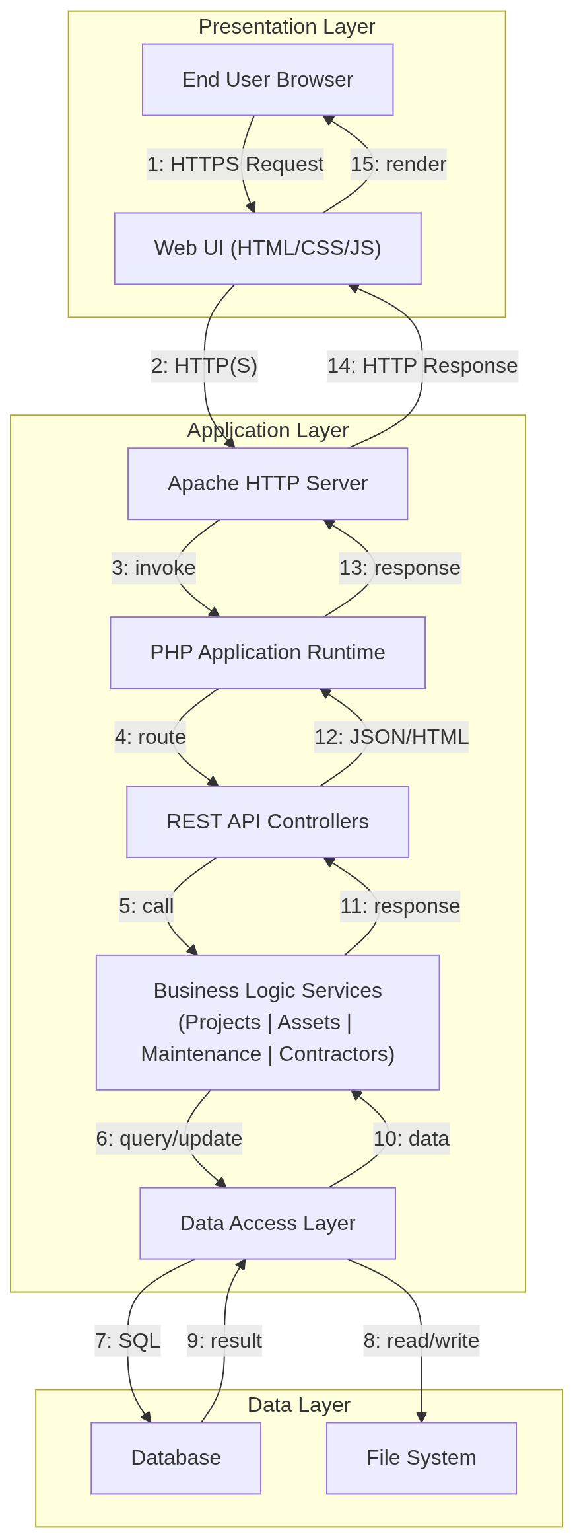

12.2 Integration Architecture (SmartGov)

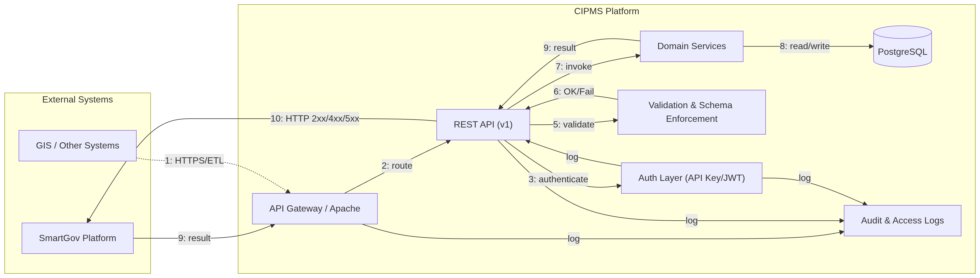

Controls Illustrated: - Transport security (HTTPS/TLS) - Authentication (API Key/JWT) - Input validation & schema enforcement - Standardised responses (HTTP status codes) - Centralised audit logging

12.3 Deployment Architecture (Cloud – South Africa)

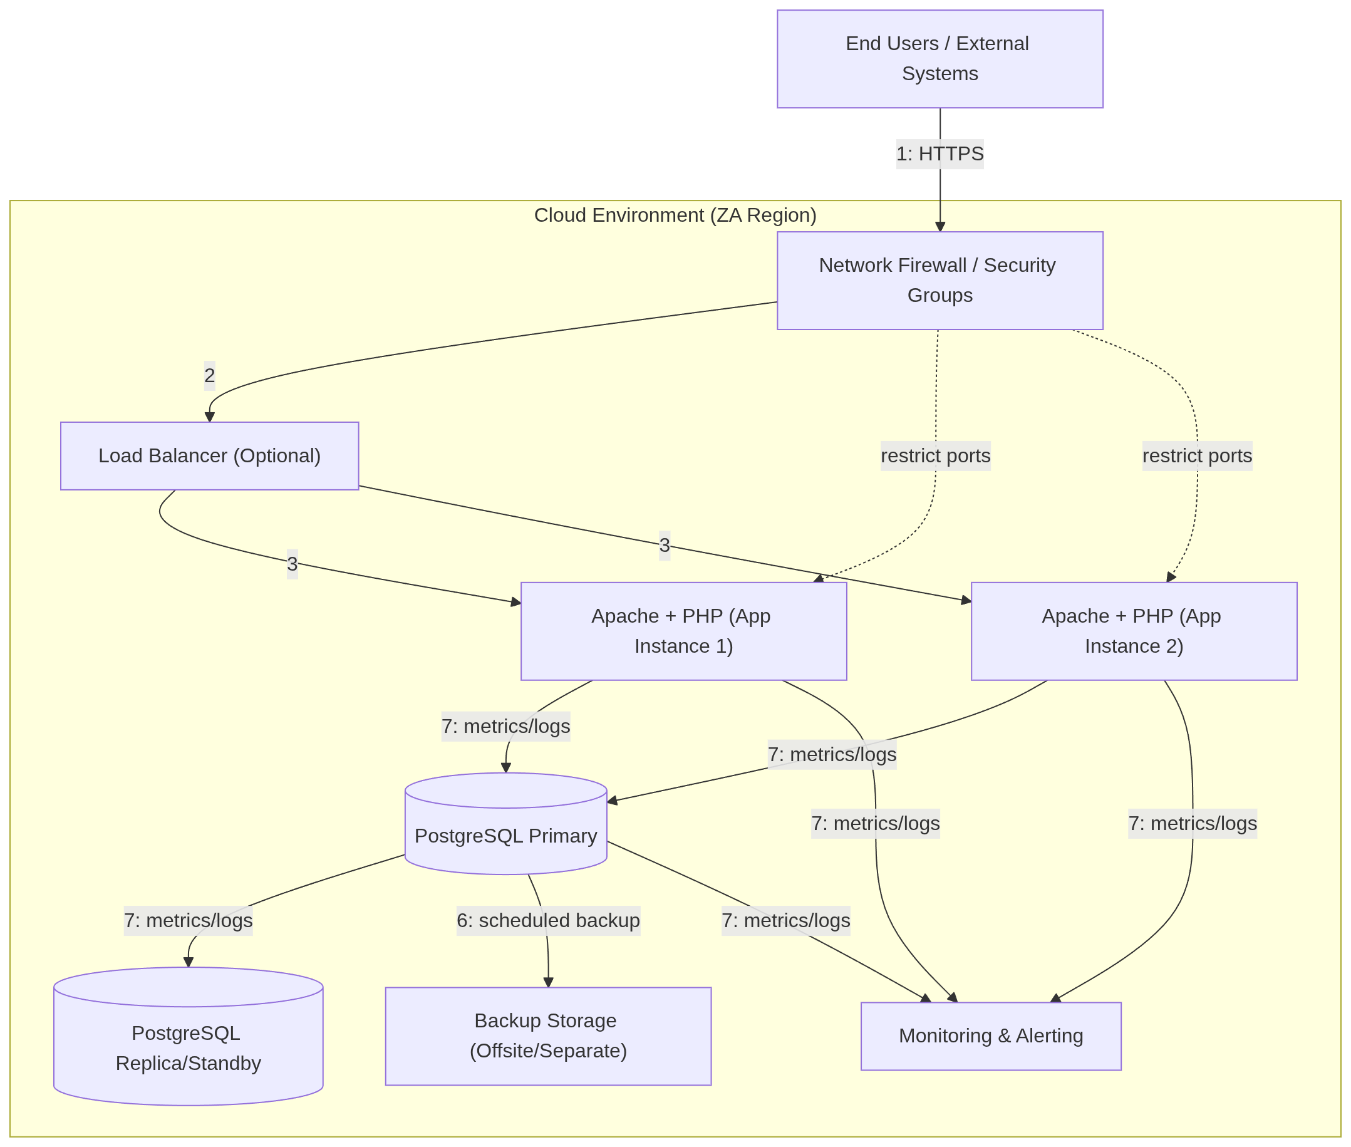
Operational Characteristics: - Horizontal scaling via multiple web instances - Database replication for resilience - Offsite backups for recovery - Centralised monitoring and alerting - Network-level access controls

12.4 Data Flow (Create Work Order – Example Sequence)

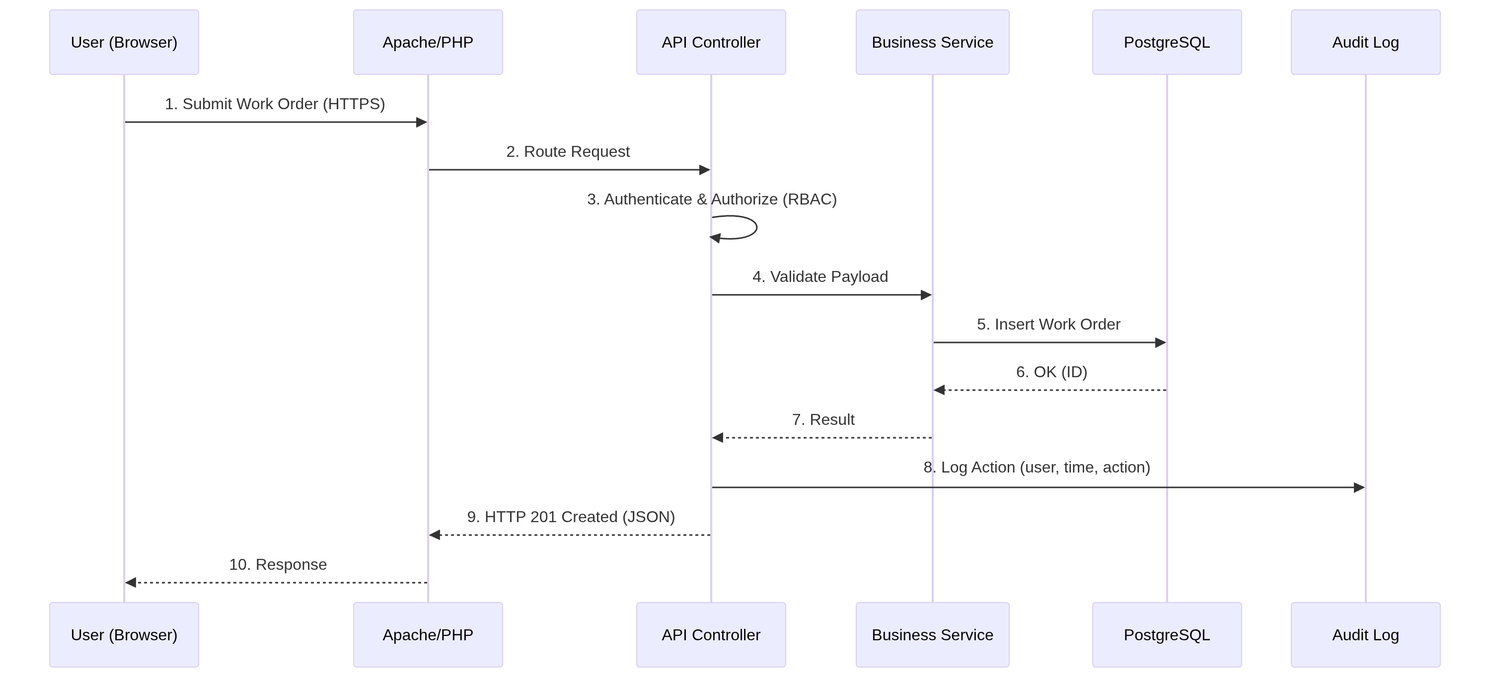
Assurances Provided: - End-to-end traceability (audit logs) - Input validation before persistence - Transactional database operations - Standardised HTTP responses

13. CONCLUSION
This document provides a detailed system architecture addressing integration, security, operational, and governance requirements necessary for audit compliance and enterprise deployment.

